Jack Melcher

67574625

2/9/2017

EECS 101

Hw4

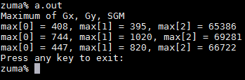

Figure 1: The maximum values for the three images

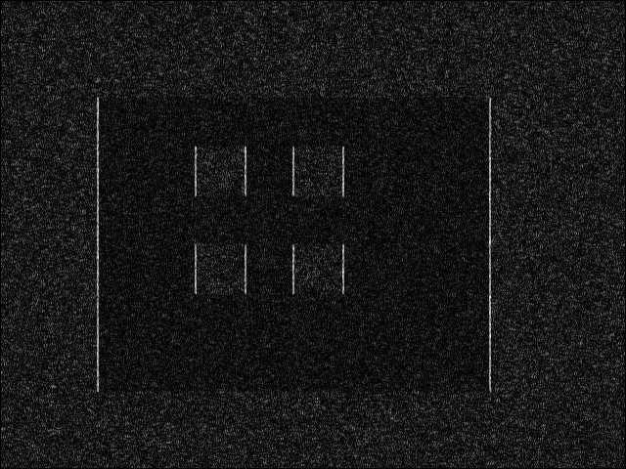

Figure 2: Gx image 1

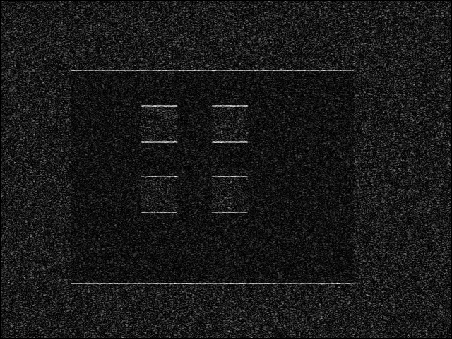

Figure 3: Gy image 1

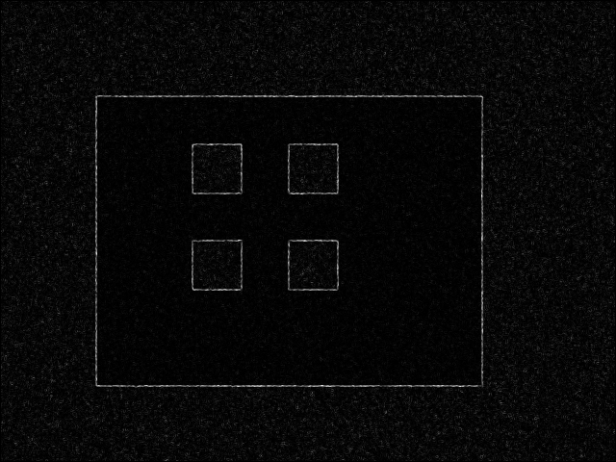

Figure 4: SGM image 1

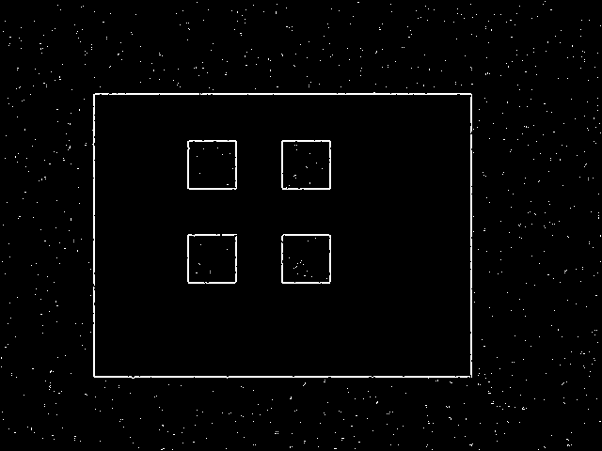

Figure 5: Binary image 1, Threshold for image 1 = 45



Figure 6: Gx image 2



Figure 7: Gy image 2



Figure 8: SGM image 2



Figure 9: Binary image 2, Threshold for image 2 = 5

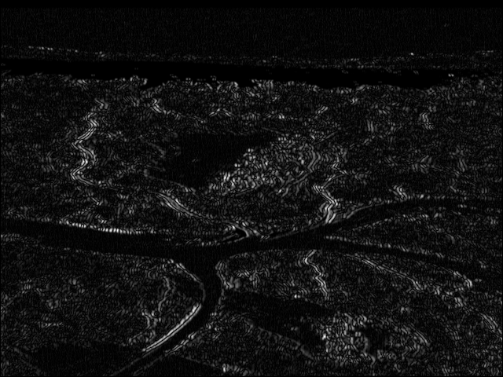

Figure 10: Gx image 3

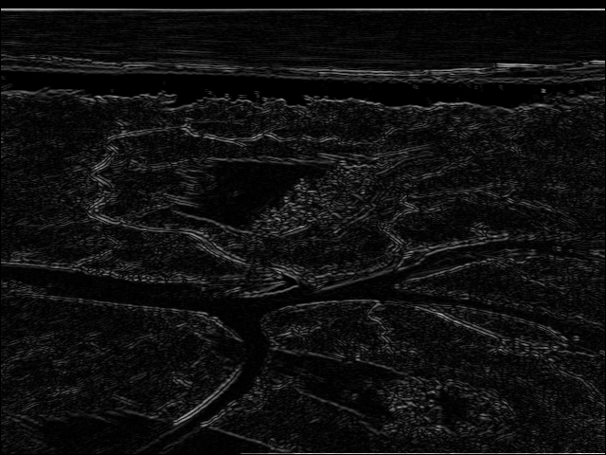

Figure 11: Gy image 3

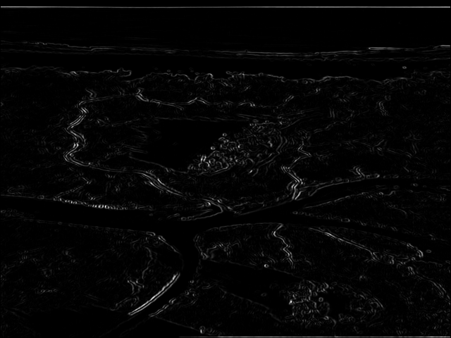

Figure 12: SGM image 3

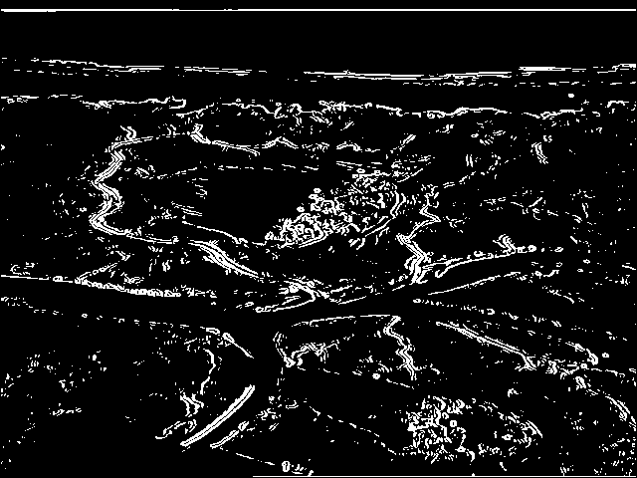

Figure 13: Binary image 3, Threshold for image 3 = 15